Threat Intelligence Integration Report
Objective
The objective of this exercise was to understand how threat intelligence can be integrated into Security Operations Center (SOC) workflows to improve threat detection, alert enrichment, and proactive threat hunting. The activity focused on importing threat intelligence feeds, validating indicators of compromise (IOCs), enriching alerts, and conducting threat-hunting operations using intelligence data.
Tools Used
- Wazuh
- AlienVault OTX
- TheHive
- MITRE ATT&CK Framework
Threat Intelligence Overview
Threat intelligence provides information about known cyber threats, including Indicators of Compromise (IOCs), attacker tactics, techniques, and procedures (TTPs), malicious IP addresses, domains, and file hashes.
Integrating threat intelligence into SOC operations enables analysts to identify threats faster and prioritize investigations based on risk and reputation data.
Threat Feed Integration
A threat intelligence feed from AlienVault OTX was integrated into the monitoring environment. The feed contained information about known malicious IP addresses, domains, and malware indicators.
The imported intelligence was used to compare security events against known threat indicators.
IOC Matching Results
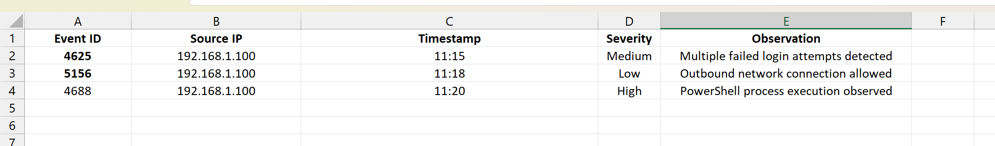
The matching process successfully identified indicators associated with suspicious activity.
Alert Enrichment
Threat intelligence data was used to enrich security alerts with additional contextual information. Alert enrichment provides analysts with valuable details such as threat reputation, historical activity, and known malicious associations.
Enriched Alert Data
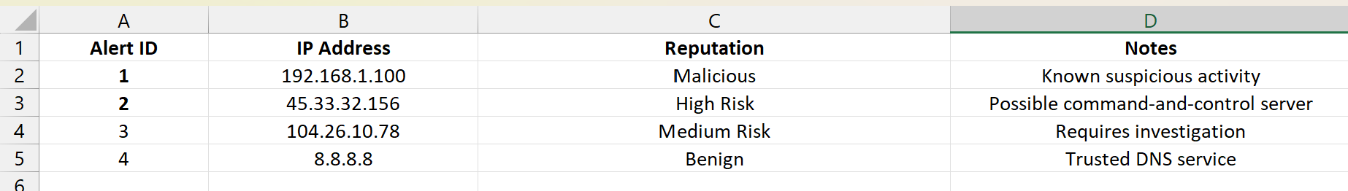
The enrichment process improved analyst awareness and assisted in prioritizing security events.
Threat Hunting Activity
A threat-hunting exercise was conducted using the MITRE ATT&CK technique T1078 (Valid Accounts). Authentication logs were reviewed to identify suspicious login behavior and possible misuse of legitimate user accounts.
Analysts searched for unusual login times, repeated authentication attempts, and access from unfamiliar IP addresses.
Findings
- Multiple authentication attempts were detected outside normal business hours.
- One user account exhibited repeated login attempts from an unfamiliar source IP.
- No confirmed compromise was identified.
- Activity was flagged for continued monitoring.
The exercise demonstrated how threat intelligence can support proactive threat hunting by guiding analysts toward high-risk behaviors and known attack techniques.
Benefits of Threat Intelligence Integration
- Faster identification of malicious activity.
- Improved alert prioritization.
- Enhanced incident investigation.
- Better visibility into attacker behavior.
- Support for proactive threat-hunting activities.
Results
The integration of threat intelligence successfully enhanced the SOC monitoring environment. Imported intelligence feeds provided additional context for alerts and enabled IOC matching against known threats. Alert enrichment improved investigation efficiency, while threat-hunting activities demonstrated the value of intelligence-driven security operations.

Conclusion
Threat intelligence plays a critical role in modern SOC operations by providing actionable information about known threats and attacker behavior. Through IOC matching, alert enrichment, and intelligence-driven threat hunting, organizations can improve detection capabilities and respond more effectively to potential security incidents. The objectives of this exercise were successfully achieved.

